NAME:

rEGISTRATION NUMBER:

COMPUTER NETWORKS - Protocols

SUBJECT CODE: CS01408



**Saveetha institute of Medical and Technical Science**

**Saveetha School of Engineering**

**COMPUTER SCIENCE AND ENGINEERING PROGRAMME**

**:**

**INDEX**

|  |  |  |  |  |
| --- | --- | --- | --- | --- |
| **S.NO** | **DATE** | **EXPERIMENT NAME** | **MARKS** | **SIGN** |
| 1. |  | CRIMPING AND CLAMPING OF STRAIGHT THROUGH AND CROSS OVER CABLE |  |  |
| 2. |  | CREATION AND DEMONSTRATION OF DIFFERENT NETWORK TOPOLOGIES USING PACKET TRACER |  |  |
| 3. |  | IMPLEMENTATION OF CRC (CYCLIC REDUNDANCY CHECK) MECHANISM USING C |  |  |
| 4. |  | IMPLEMENTATION OF STOP AND WAIT PROTOCOL USING C |  |  |
| 5. |  | CONFIGURATION OF FRAME RELAY MECHANISM IN PACKET TRACER USING STATIC MAPS |  |  |
| 6. |  | CONFIGURATION OF OSPF USING PACKET TRACER |  |  |
| 7. |  | CONFIGURATION OF DYNAMIC ROUTING-RIP IN PACKET TRACER |  |  |
| 8. |  | IMPLEMENTATION OF SERVER – CLIENT USING SOCKET PROGRAMMING |  |  |
| 9. |  | ANALYSIS OF IP, TCP AND UDP PROTOCOL HEADERS USING WIRESHARK PACKET ANALYZER |  |  |
| 10. |  | DEMONSATRATION OF PING OPERATION USING ICMP IN WIRE SHARK |  |  |
| 11. |  | CONFIGURATION OF DOMAIN NAME SERVICE |  |  |
| 12. |  | CONFIGURATION OF DHCP (DYNAMIC HOST CONFIGURATION PROTOCOL) IN PACKET TRACER |  |  |
| 13. |  | CONFIGURATION OF FIREWALL IN PACKET TRACER |  |  |

Exercise No: 01 Date:

**CRIMPING AND CLAMPING OF STRAIGHT THROUGH AND CROSS OVER CABLE**

AIM:

DESCRIPTION:

* **Straight Through Cable** -

An Ethernet cable that is used to connect an end device and a network device is called as a straight through cable.

* **Cross Over Cable** –

An Ethernet cable that is used to connect any two end devices together or any two network devices together is called a cross over cable.

COLOR CODING:

|  |  |
| --- | --- |
| **T568A Standard** | |
| Pin 1 | White/Green |
| Pin 2 | Green |
| Pin 3 | White/Orange |
| Pin 4 | Blue |
| Pin 5 | White/Blue |
| Pin 6 | Orange |
| Pin 7 | White/Brown |
| Pin 8 | Brown |

|  |  |
| --- | --- |
| **T568B Standard** | |
| Pin 1 | White/Orange |
| Pin 2 | Orange |
| Pin 3 | White/Green |
| Pin 4 | Blue |
| Pin 5 | White/Blue |
| Pin 6 | Green |
| Pin 7 | White/Brown |
| Pin 8 | Brown |

PROCEDURE:

1. Strip about 1.5 cm of cable shielding from both ends, using a crimping tool
2. Untangle the wires and arrange them according to the coding
3. After the order is attained, bunch them together
4. Hold the RJ45 plug with the clip slide facing away from you
5. Push the cable right in- the notch at the end of the plug should just be over the cable shielding
6. When the wires are sitting tightly in the plug, insert in the plug into the crimping tool and push down
7. Repeat the same method for the other end, using T568 standard color coding
8. Now test this cable by connecting two systems directly together

RESULT:

Exercise No: 02 Date:

**CREATION AND DEMONSTRATION OF DIFFERENT NETWORK TOPOLOGIES USING PACKET TRACER**

AIM:

PROCEDURE:

1. Start packet tracer

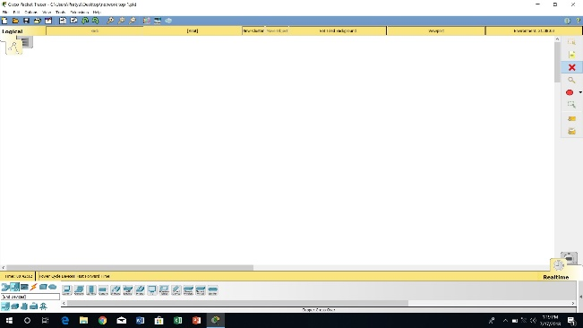

1. Click on the ‘END DEVICES’ and choose ‘generic’.
2. Now click on the screen. The end device will be displayed

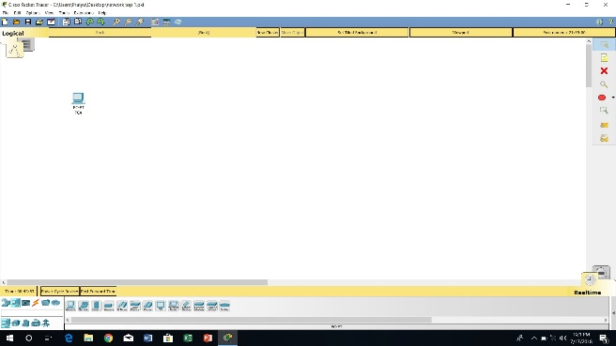

1. Repeat the same process three more end devices
2. Click on the ‘network devices’
3. Select ‘hub’-‘generic’
4. Now select a spot in between the first two end devices on the screen to display the hub
5. Select ‘switch’-‘2960’

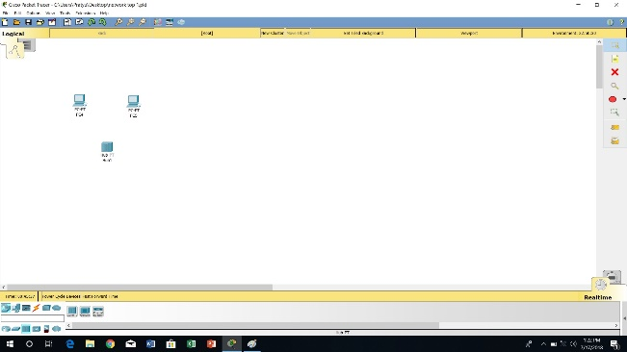

1. Click on the screen in between the other two devices to display the switch
2. Click on the ‘connections’
3. Select the copper wire through wire

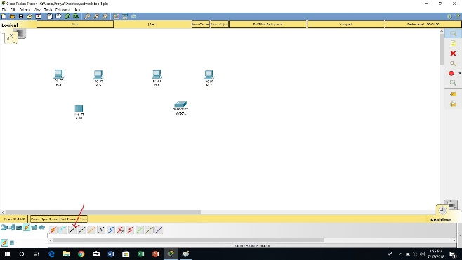

1. Now click on the first end device
2. Choose fast Ethernet

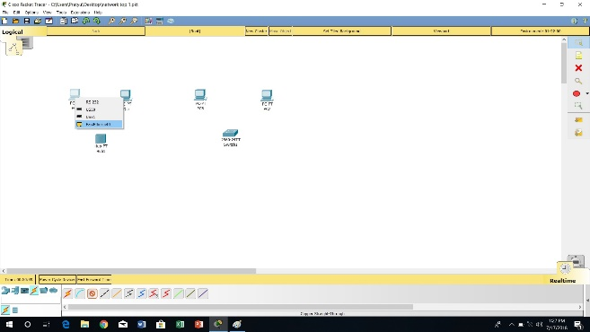

1. Drag the cursor to hub
2. Click on the hub and choose fast Ethernet 0

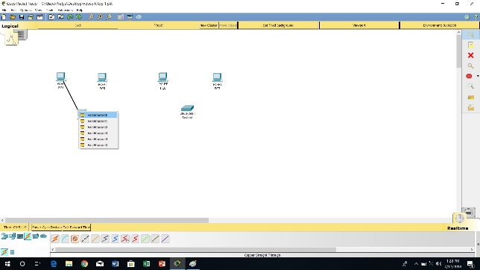

1. Notice the green link lights on both the system and hub. this indicates that the link is activate
2. Do the same for the second end device and this time choose fast Ethernet 1 on hub
3. Similarly click on the third end device

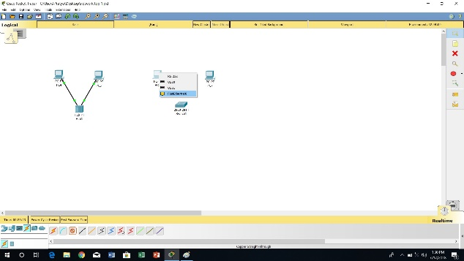

1. Choose fast Ethernet
2. Drag the cursor to switch
3. Click once on the switch and choose fast Ethernet 0/1
4. Notice the green link light and amber light on the system and switch respectively this indicates that the switch port is temporarily not forwarding frames, while it goes through the stages for spanning tree protocol (STP) process
5. After about 30 seconds the amber light will change to green
6. Repeat the same process with the fourth end device and choose fast Ethernet 0/2 on switch

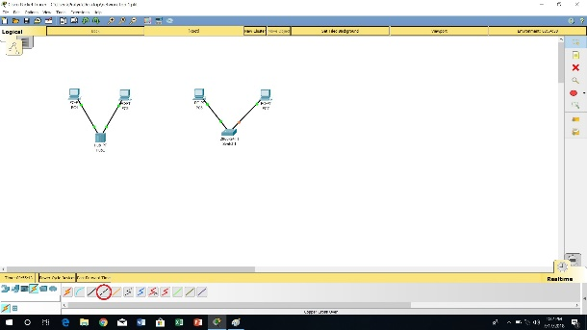

1. Click on the ‘connections’
2. Select the ‘copper cross-over’ wire
3. Move the connections cursor to hub and click once
4. Select fast Ethernet 5
5. Move the connections cursor to switch and click once
6. Select fast Ethernet 0/4

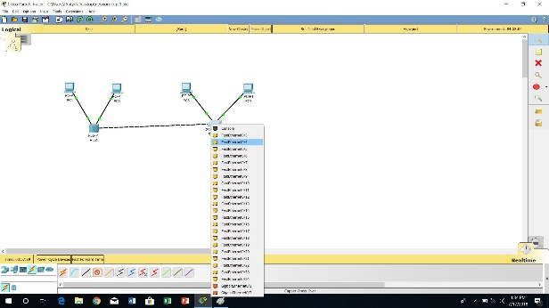

1. Now click once on the first end device
2. Choose the ‘configuration’ tab and fast Ethernet 0

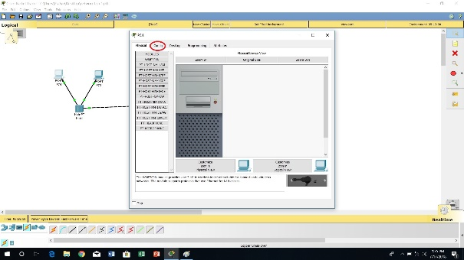

1. Add the IP address under the IP configuration selection

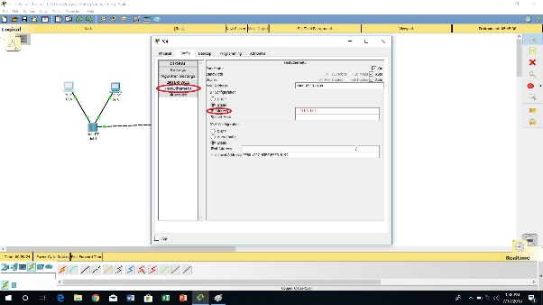

1. Choose the Desktop tab and opt the ‘command prompt’
2. Type ‘ipconfig’ and then ping the IP address of the desired end device

OUTPUT:

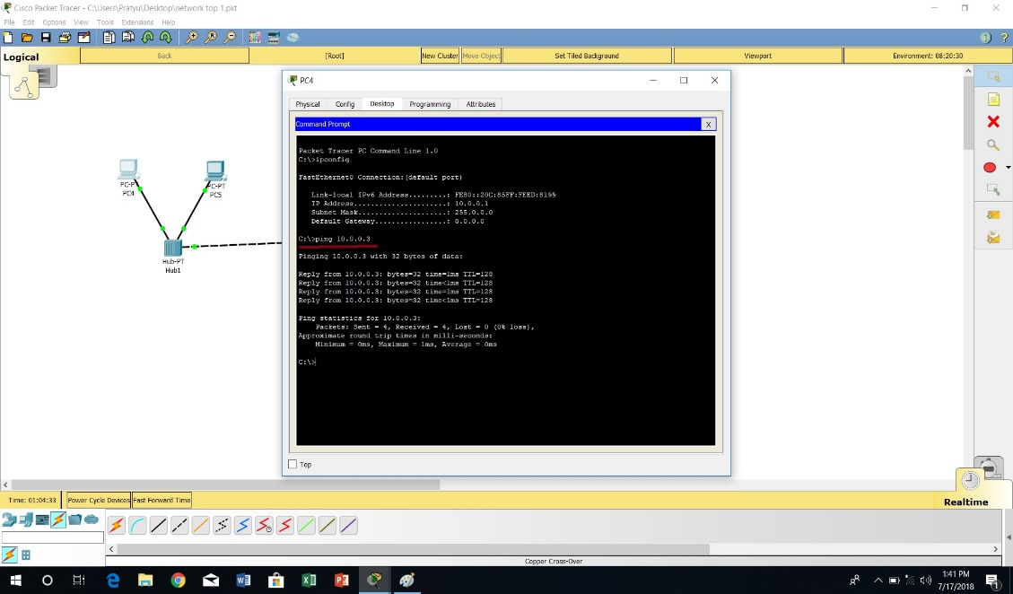

RESULT:Exercise No: 03 Date:

**IMPLEMENTATION OF CRC (CYCLIC REDUNDANCY CHECK) MECHANISM USING C**

AIM:

ALGORITHM:

STEP 1:-start the program

STEP 2:-accept the number of bits in the input data stream (n)

STEP 3:-accept the number of bits in the divisor (d)

STEP 4:-accept the input bits and the divisor bits

STEP 5:-append (d-3)’0’bits to the input data bits

STEP 6:-perform binary division

STEP 7:-remove the appended ‘0’bits and append the remainder bits to the original data bits

STEP 8:-again perform binary division

STEP 9:-if the remainder is zero then there is no error in the transmitted bits else the received bits are in error

STEP 10:-stop the program

CODING:

**1**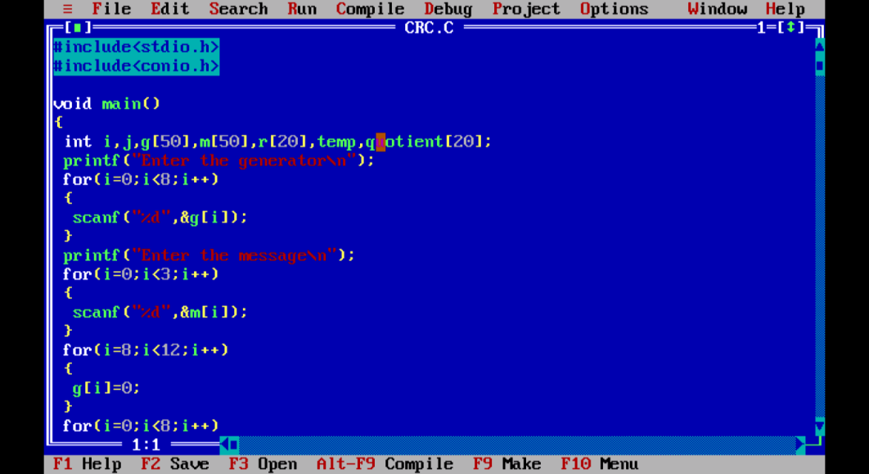

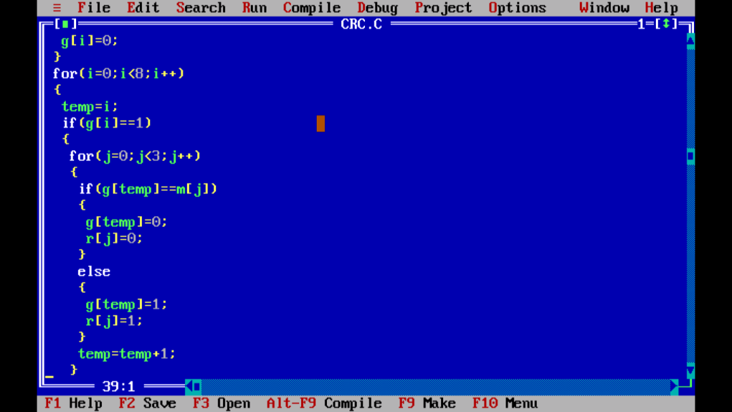

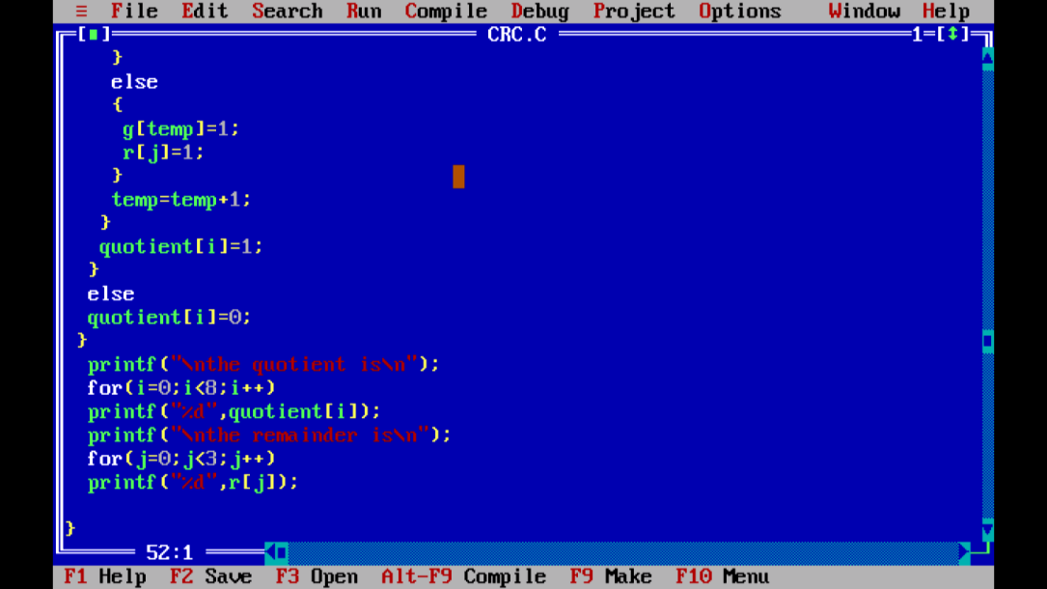

OUTPUT:

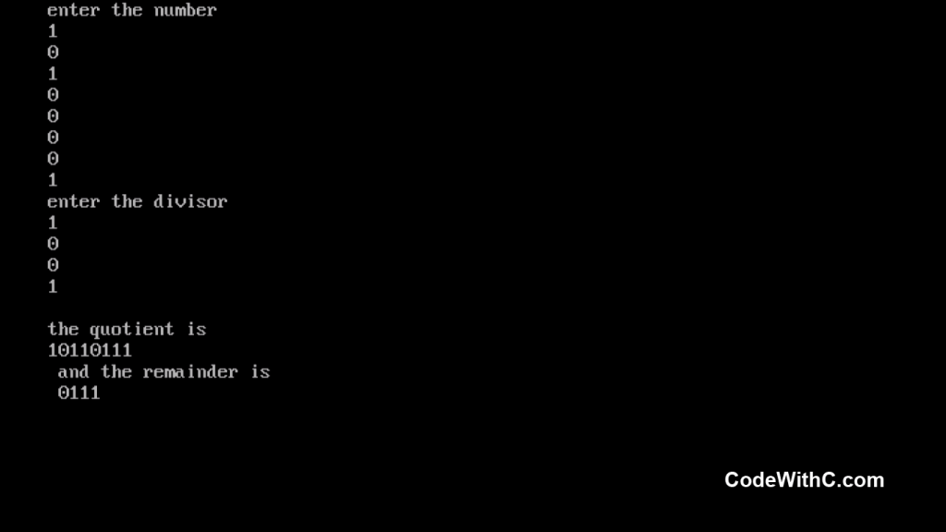

RESULT:

Exercise No: 04 Date: **IMPLEMENTATION OF STOP AND WAIT PROTOCOL USING C**

AIM:

ALGORITHM:

STEP1:-Start the program

STEP2:-generate a random that gives the total number of frames to be transmitted

STEP3:-Transmit the first frame

STEP4:-receive the acknowledgement for the first frame

STEP5:-Transmit the next frame

STEP6:-find the remaining frames to be sent

STEP7:-if an acknowledgement is not received for a particular frame retransmit that frame alone again

STEP8:-repeat the steps 5 to 7 till the number of remaining frames to be sent becomes zero

STEP9:-Stop the program

CODING:

# include <stdio.h>

# include <conio.h>

# include <stdlib.h>

void main()

{

int i, j, noframes, x,x1=10,x2;

clrscr();

for(i=0;i<200;i++)

rand ();

nonframes = rand ()/200;

i=1;

j=1;

nonframes = nonframes%8;

printf(“\n number of frames is %d”, nonframes);

getch();

while(nonframes>0)

{

print f (“\n sending frame is d”,i);

srand (x1++);

x= rand () %10;

if(x%2==0)

{

for(x2=1; x 2<2;x 2++)

{

print f (“waiting for %d seconds\n”x2);

sleep(x2);

}

print f (“/n sending frame %d”, i);

srand (x1++);

x=rand () %10;

}

print f (“/n acknowledgment for frame %d” ,j);

no frames -=1;

i++;

j ++;

}

print f(“/n end of stop and wait protocol”);

getch ();

}

OUTPUT:

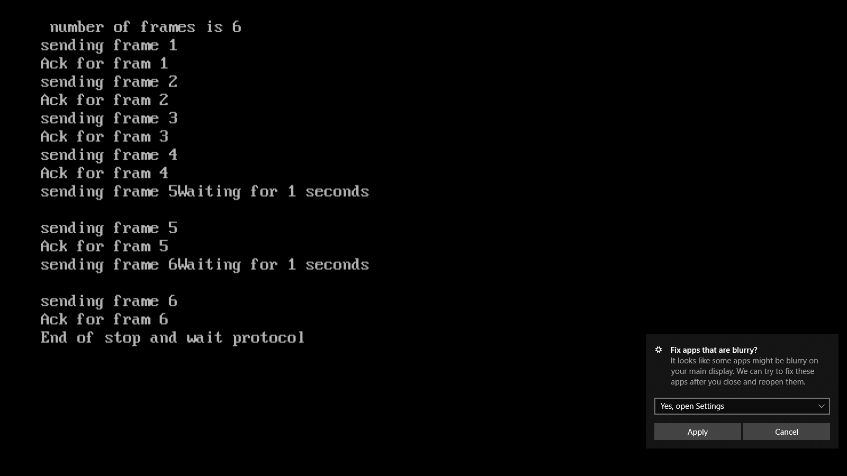

RESULT:

Exercise No: 05 Date:

**CONFIGURATION OF FRAME RELAY MECHANISM IN PACKET TRACER USING STATIC MAPS**

AIM:

To configure and implement frame relay mechanism in packet tracer using static maps.

PROCEDURE:

1. Start the packet tracer
2. Now choose the end devices i.e, 2 generic devices and place them in the workspace
3. Also select server-pt in the end devices
4. Select network devices i.e, 4 routers and two switches along with1 wan emulation
5. Router – 1841, switches-2960 and cloud
6. Now connect end devices and switches using a straight through cable
7. Connect switches to router-1 and router-3 in the similar manner

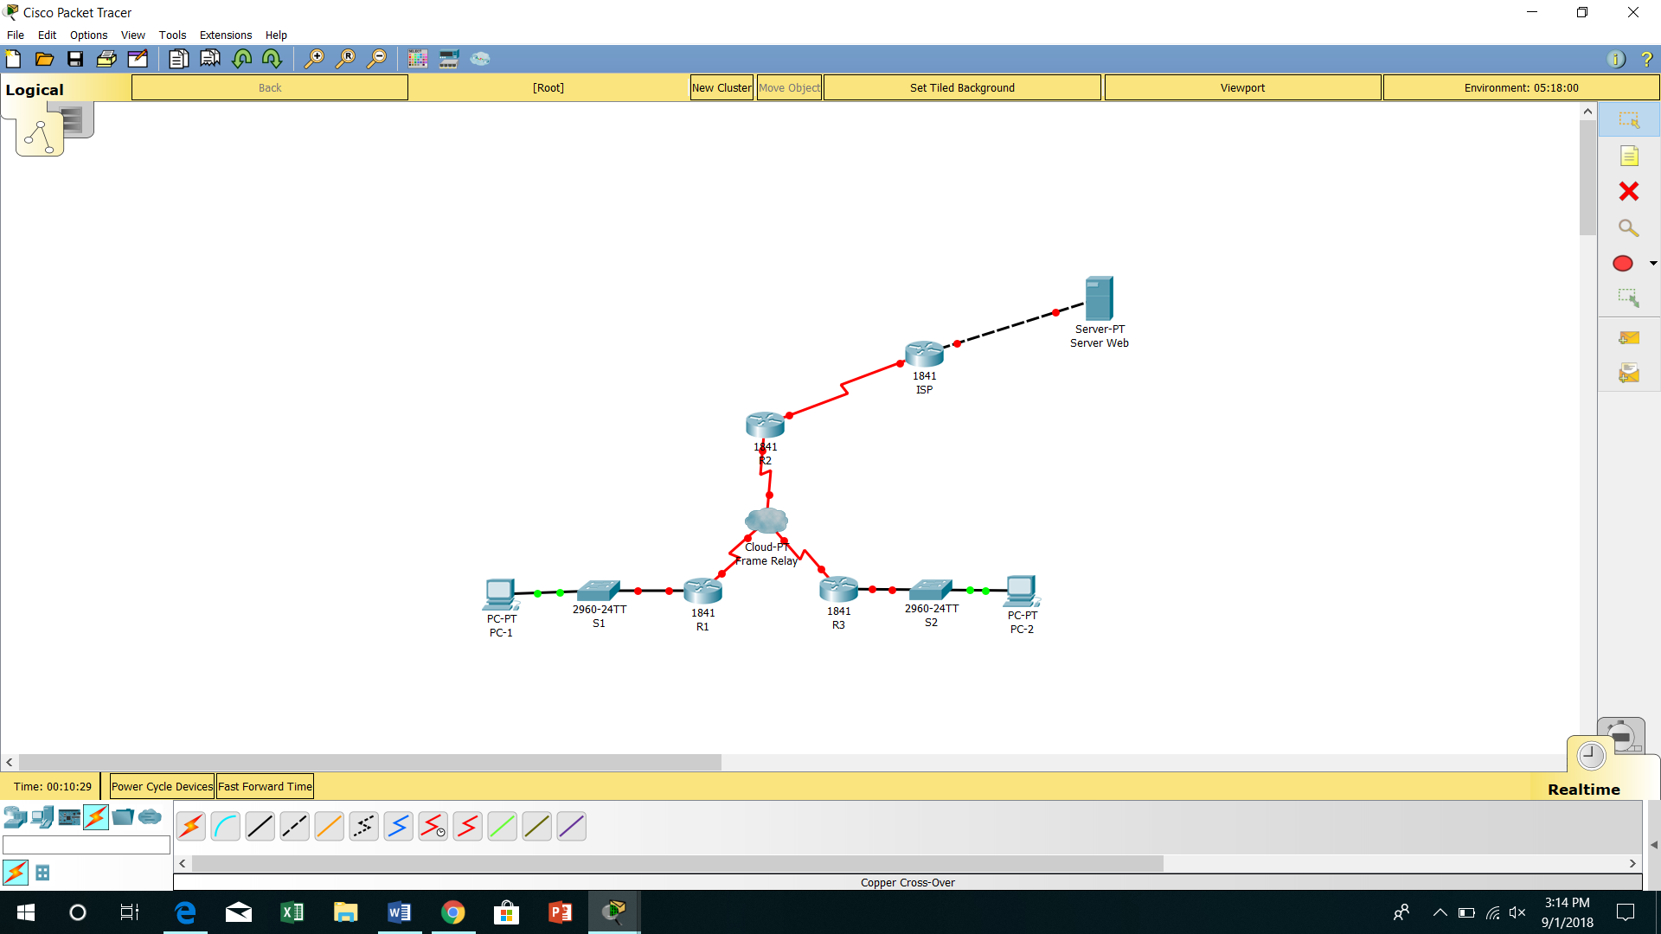

1. Now open the frame relay(cloud-pt)
2. Click on the ‘serial-0’ under interface and add DLCI number and name for it
3. Similarly give DLCL number and name for the other routers
4. Now click on the frame relay and configure the ports and sub links

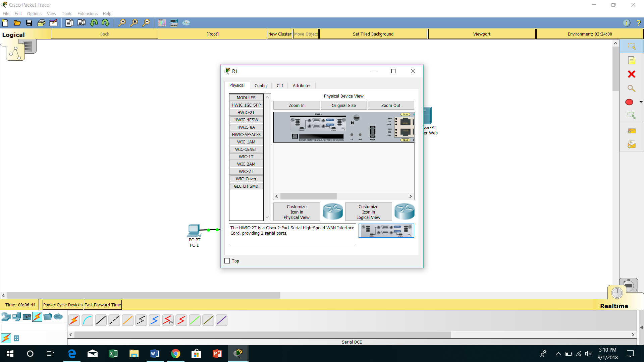

1. Configure the routers with hostname and IP address on all interfaces
2. Configure encapsulation on serial o/o/o interface of R1

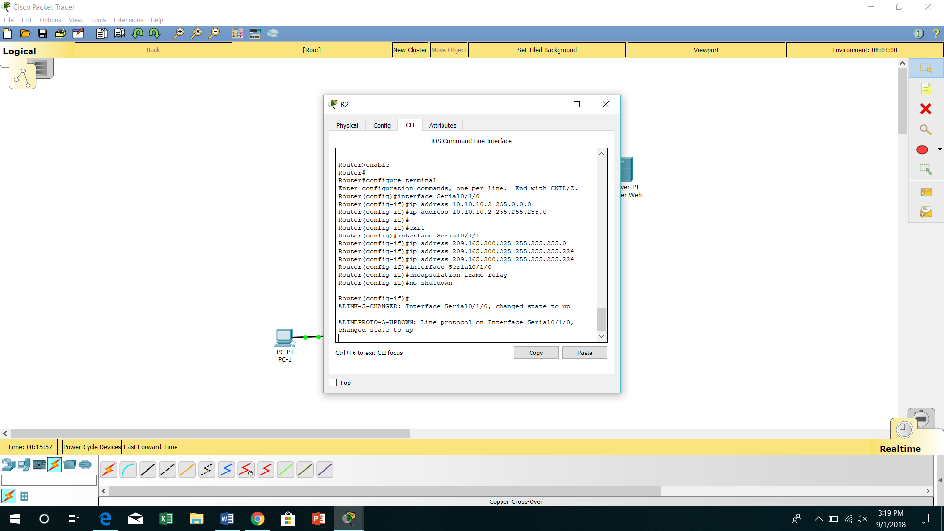

1. Similarly configure frame relay encapsulation on the serial o/o/o interface of R2 and R3
2. Test the connectivity from command line on PC1 and ping PC1 to PC2.but the pinging process should fail since the router R1,does not know the address of PC1
3. R1 must be configure with a frame relay map so that it can be find the next hop destination to reach the network
4. Now click results your completion percentage should be 40%
5. Configure static frame relay maps
6. Configure static maps on R1 &R2 &R3
7. After this your completion percentage will be 80%
8. Configure frame relay LMI type, cloud contains switches that are using ANSI as LMI type
9. Configure ANSI by entering command on serial interface
10. Now your completion percentage will be 100%
11. Ping PC1 to PC2 your process will be successful or else make sure that entered commands are specified

OUTPUT:

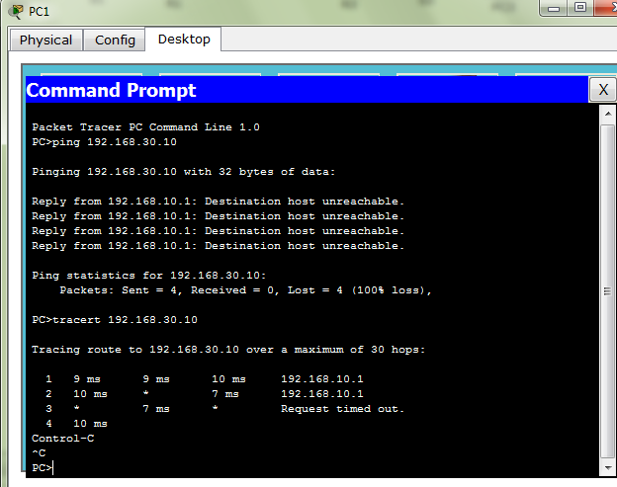

RESULT:Exercise No: 06 Date:

**CONFIGURATION OF OSPF USING PACKET TRACER**

AIM:

To configure and implement OSPF mechanism using packet tracer.

PROCEDURE:

1. Start the packet tracer.
2. Now select the Routers, Switches and Systems from the Networks devices and End devices and place in the workspace.
3. Configure the Routers and disable DNS lookup.
4. Configure the interfaces on R1, R2 and R3 routes with the IP addresses respectively.

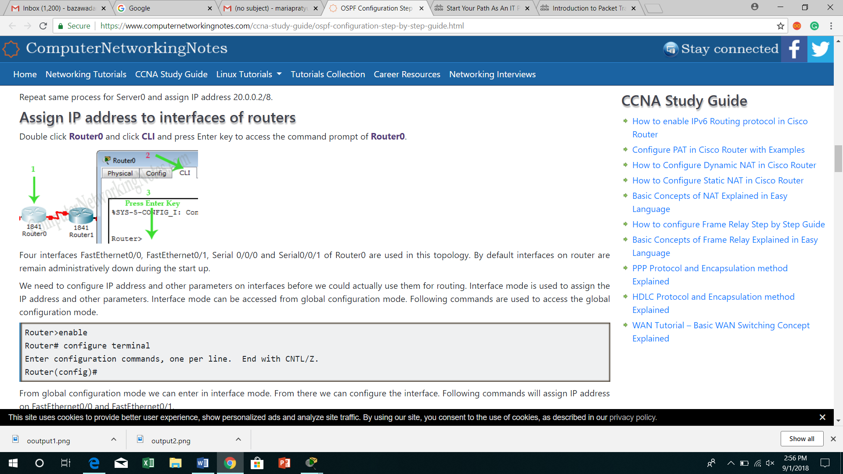 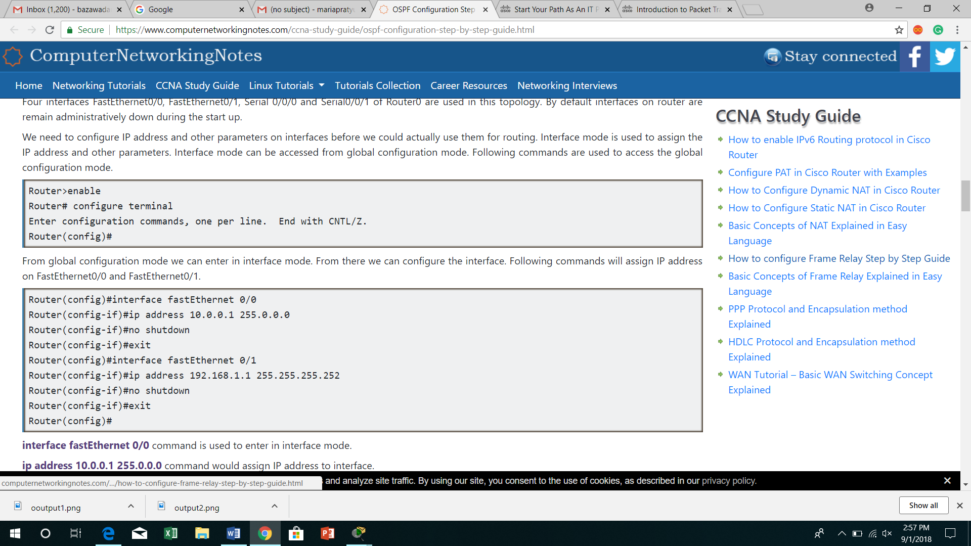

1. Use show IP interface brief command to verify the IP address.
2. Configure the Ethernet interfaces of PC1 and PC2.

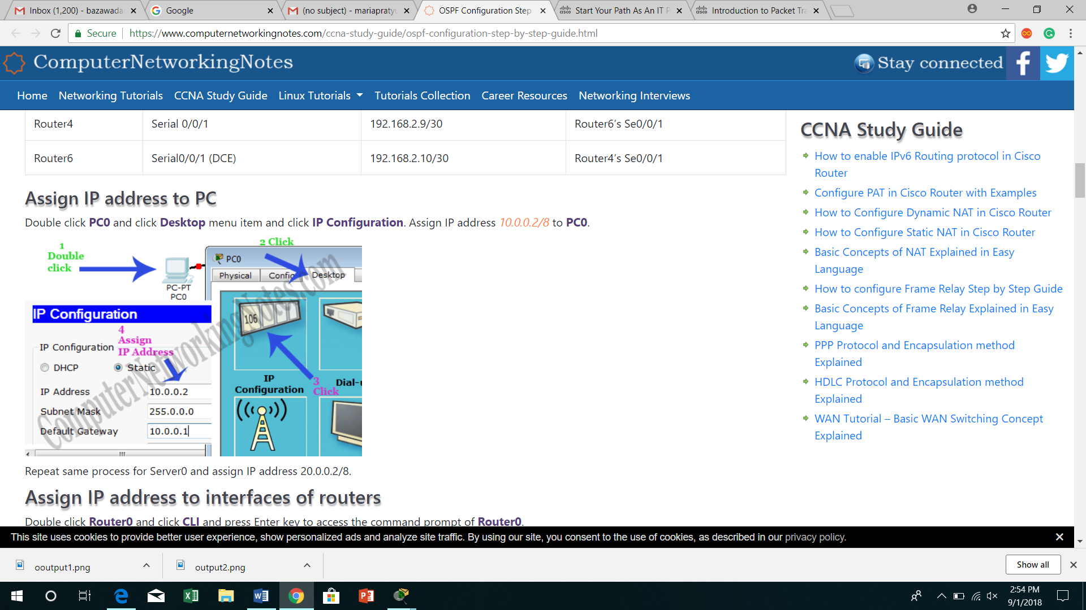

1. Use router OSPF configuration command in global configuration mode to enable OSPF in R1.
2. Configure the network statement for LAN network.
3. Configure the router to advertise the network attached to serial 0/0/0 interface and serial0/0/1 interface.
4. After completing OSPF configuration for R1, return to privileged EXEC mode.
5. Similarly configure routers R3 and R2 for the OSPF configuration command.
6. IP address configured with OSPF router is ID command.
7. Examine the current router ID in topology.
8. Use loopback addresses to change the router ID’s of the routers in the topology.
9. Reload the routers to force the new router ID’s to be used.
10. Use the show IP OSPF neighbors command to verify that the router Id’s have changed.
11. Remove the configured router ID with the no form of the router ID command.
12. Restart the OSPF process using clear IP OSPF process command.
13. Now create virtual link between R1, R2 by this we create a virtual link to connect area 3 to area 0.
14. R2 and R3 get updates about area 3. Now, check routing table of R3.
15. Now check the connectivity of two PC’s.

OUTPUT:

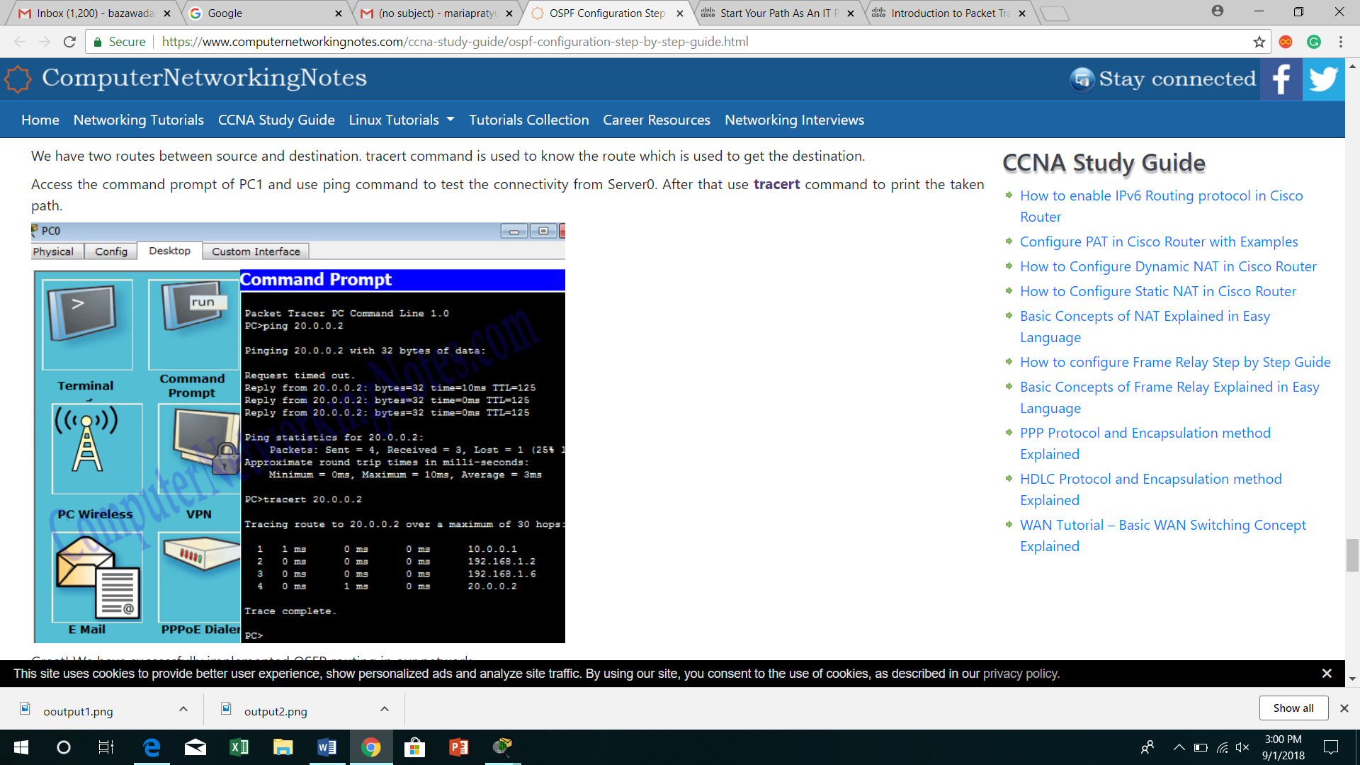

RESULT:

Exercise No: 07 Date:

**CONFIGURATION OF DYNAMIC ROUTING-RIP IN PACKET TRACER**

AIM:

PROCEDURE:

1. Start the packet tracer.
2. Now select four Generic systems from End Devices, two switches (2960-24TT) from the Network Devices and three routers from the same and place it in the workspace.

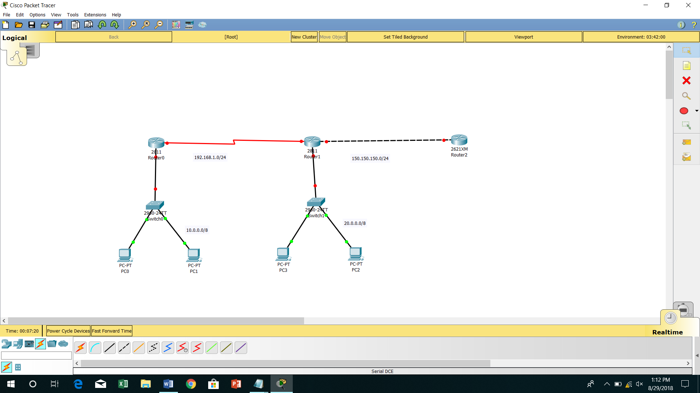

1. Now configure appropriate IP addresses on each device.
2. Give IP configuration by double clicking on PC0 and give configuration in respective taskbar.

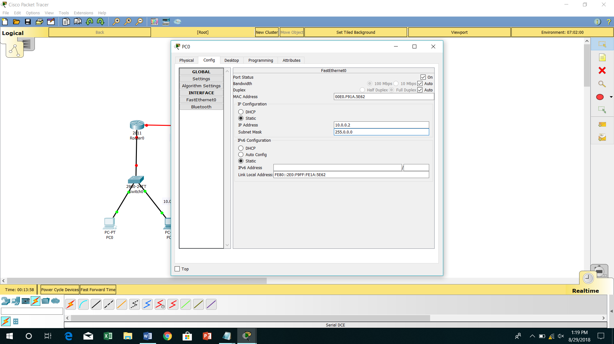

1. Double click on Router and click CL1 and press enter to access the command prompt of Router.

* Give the following type command to configure RIP routing
* Router1(config)#Router rip
* Router1(config-router)#network 10.0.0.0
* Router1(config-router)#network 192.168.1.0
* Router1(config-router)#exit

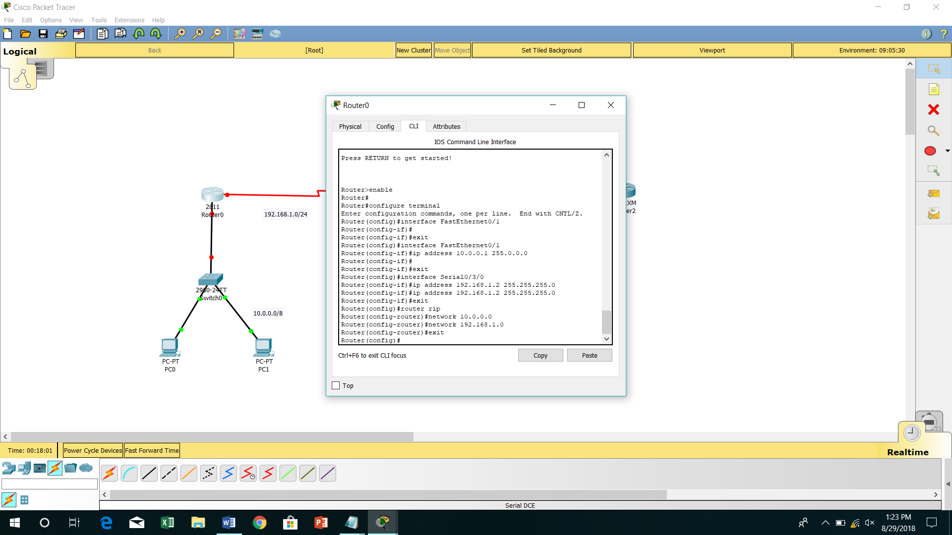

1. The default version of RIP is RIPv1. In the later section, RIPv2 routing will be configured.
2. Enable RIP routing protocol from global configuration mode.
3. Tell RIP routing protocol which network you want to advertise.
4. Do the same for Router 2.
5. Access the command prompt of PC1 and ping PC0.
6. Finally the RIP routing is successfully implemented.
7. For cross checking we have uploaded a configured topology on our server.
8. We can download and use that if the same output is not obtained.

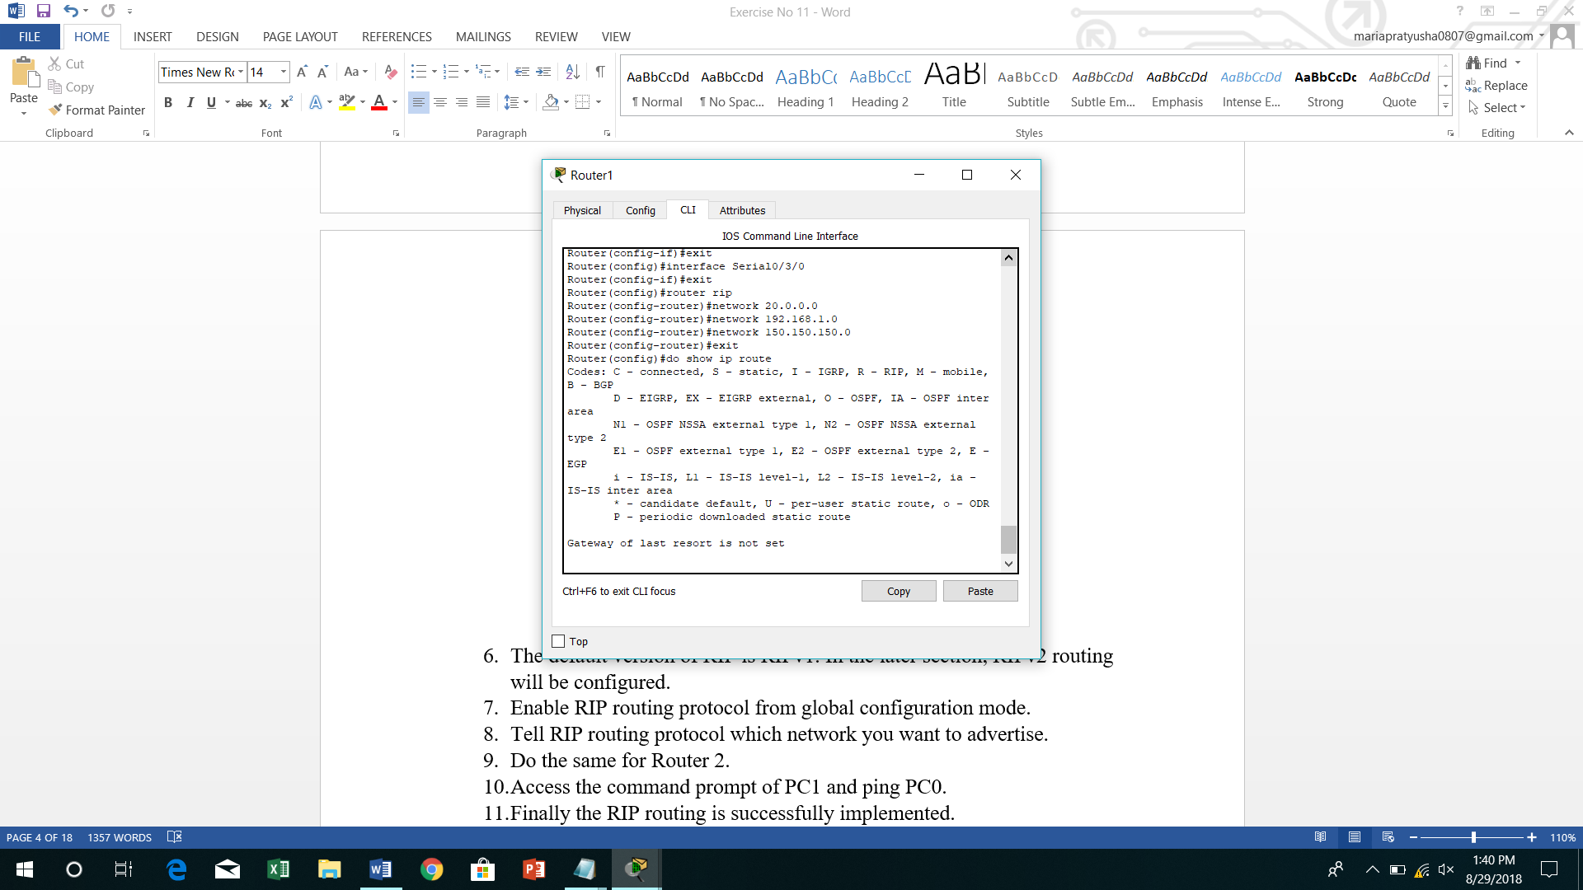

1. Download RIP Routing practice topology.
2. RIP protocol automatically manages all routes for us.
3. If one route goes down, it automatically switches to another.
4. Currently there are two routes between PC0 and PC1.
5. We can use tracert command to verify it.
6. Now if Router 1 is down, we can stimulate this situation by removing the cable attached between routes.
7. So far we are running RIP routing protocol and have another route to destination.
8. Use tracert command again to see the magic of dynamic routing.

OUTPUT:

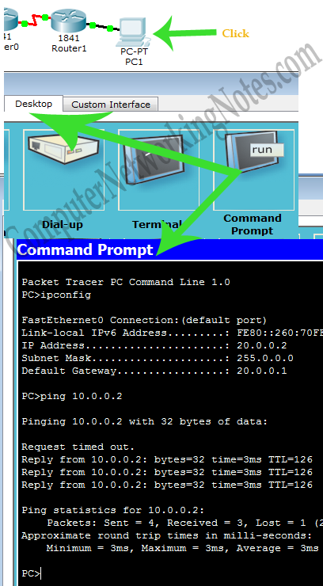 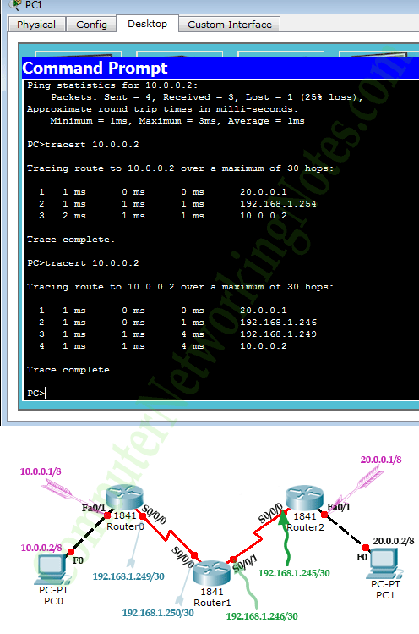

RESULT:

Exercise No: 08 Date:

**IMPLEMENTATION OF SERVER – CLIENT USING SOCKET PROGRAMMING**

AIM:

PROCEDURE:

* SERVER-

1. Start the program.
2. Generate an object for the object **ServerSocket** and display if the server is ready.
3. Create a new object for Socket and accept the message using the **BufferedReader** and display with the help of **OutputStream**.
4. Send the message to the client by using the keywords **PrintWrite** and **InputStream**.
5. Now use a while loop to send and receive messages with necessary commands.
6. Stop the program.

* CLIENT-

1. Start the program.
2. Give the IP address of the system with which you want to communicate or you can give “Local Host”.
3. Do the same as Step 3 and 4 in the above, but here, give the receive command after the send message.
4. Stop the program.

CODING:

* SERVER:

import java.net.*;

import java.io.*;

public class Server

{

public static void main(String args[])throws Exception

{

ServerSocket Ssoc=new ServerSocket(3000);

System.out.println("Server is ready!!");

Socket soc=Ssoc.accept();

BufferedReader KeyRead=new BufferedReader(new InputStreamReader(System.in));

OutputStream OStream = soc.getOutputStream();

PrintWriter pwrite=new PrintWriter(OStream,true);

InputStream iStream=soc.getInputStream();

BufferedReader receive=new BufferedReader(new InputStreamReader(iStream));

String receivemessage,sendmessage;

while(true)

{

receivemessage=receive.readLine();

System.out.println(receivemessage);

sendmessage=KeyRead.readLine();

pwrite.println(sendmessage);

pwrite.flush();

}

}

}

* CLIENT:

import java.net.*;

import java.io.*;

public class Client

{

public static void main(String args[])throws Exception

{

Socket soc=new Socket("LocalHost",3000);

BufferedReader KeyRead=new BufferedReader(new InputStreamReader(System.in));

OutputStream OStream = soc.getOutputStream();

PrintWriter pwrite=new PrintWriter(OStream,true);

InputStream iStream=soc.getInputStream();

BufferedReader receive=new BufferedReader(new InputStreamReader(iStream));

String receivemessage,sendmessage;

while(true)

{

sendmessage=KeyRead.readLine();

pwrite.println(sendmessage);

receivemessage=receive.readLine();

System.out.println(receivemessage);

pwrite.flush();

}

}

}

OUTPUT:

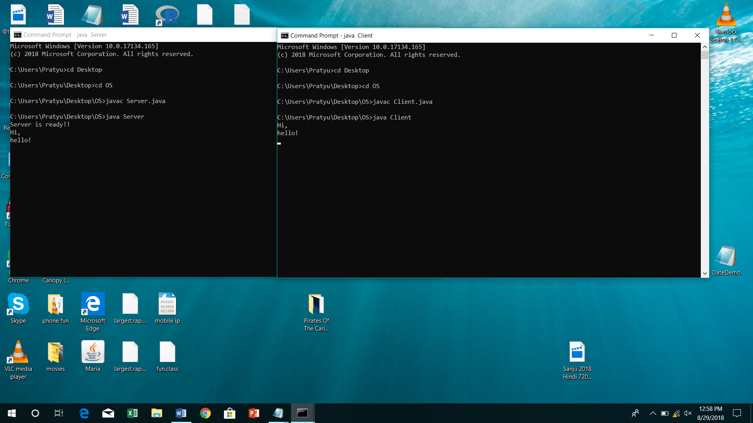

RESULT:

Exercise No: 09 Date:

**ANALYSIS OF IP, TCP AND UDP PROTOCOL HEADERS USING WIRESHARK PACKET ANALYZER**

AIM:

PROCEDURE:

1. Download and install wire shark depending on OS.
2. Connect your system to any Wi-Fi network.
3. Enable packet capturing in the appropriate network interface.
4. Start live capturing of packets.
5. Browse any webpage.
6. Stop live capturing of packets.
7. Filter the necessary protocol out of all captured packets for which you want to analyze the header.

IP HEADER:

|  |  |  |  |  |
| --- | --- | --- | --- | --- |
|  | | | | |
| Version | IHL | TDS/DSCP/ECN | TOTAL LENGTH | |
| IDENTIFIER | | | FLAGS | FRAGMENT OFFSET |
| TIME TO LIVE | | PROTOCOL | HEADER CHECKSUM | |
| SOURCE ADDRESS | | | | |
| DESTINATION ADDRESS | | | | |
| OPTIONS AND PADDING | | | | |

TCP HEADER:

|  |  |  |  |  |  |
| --- | --- | --- | --- | --- | --- |
|  | | | | | |
| SOURCE PORT | | | DESTINATION PORT | | |
| SEQUENCE NUMBER | | | | | |
| ACKNOWLEDGEMENT NUMBER | | | | | |
| DATA OFFSET | RESERVED | FLAGS | | WINDOW(SLIDING WINDOW) | |
| CHECKSUM | | | | URGENT POINTER | |
| OPTIONS | | | | | PADDING |
| DATA | | | | | |

UDP HEADER:

|  |  |
| --- | --- |
|  | |
| SOURCE PORT | DESTINATION PORT |
| LENGTH | CHECKSUM |
| DATA | |
|  | |

OUTPUT:

* IP

|  |  |  |  |  |
| --- | --- | --- | --- | --- |
|  | | | | |
| 4 | 20 bytes | DSCP | 166 | |
| 0×4131(16689) | | | 0×0000 | FRAGMENT OFFSET |
| 64 | | UDP(17) | 0×0c17(unverified) | |
| 172.18.32.210 | | | | |
| 255.255.255.255 | | | | |
| OPTIONS AND PADDING | | | | |

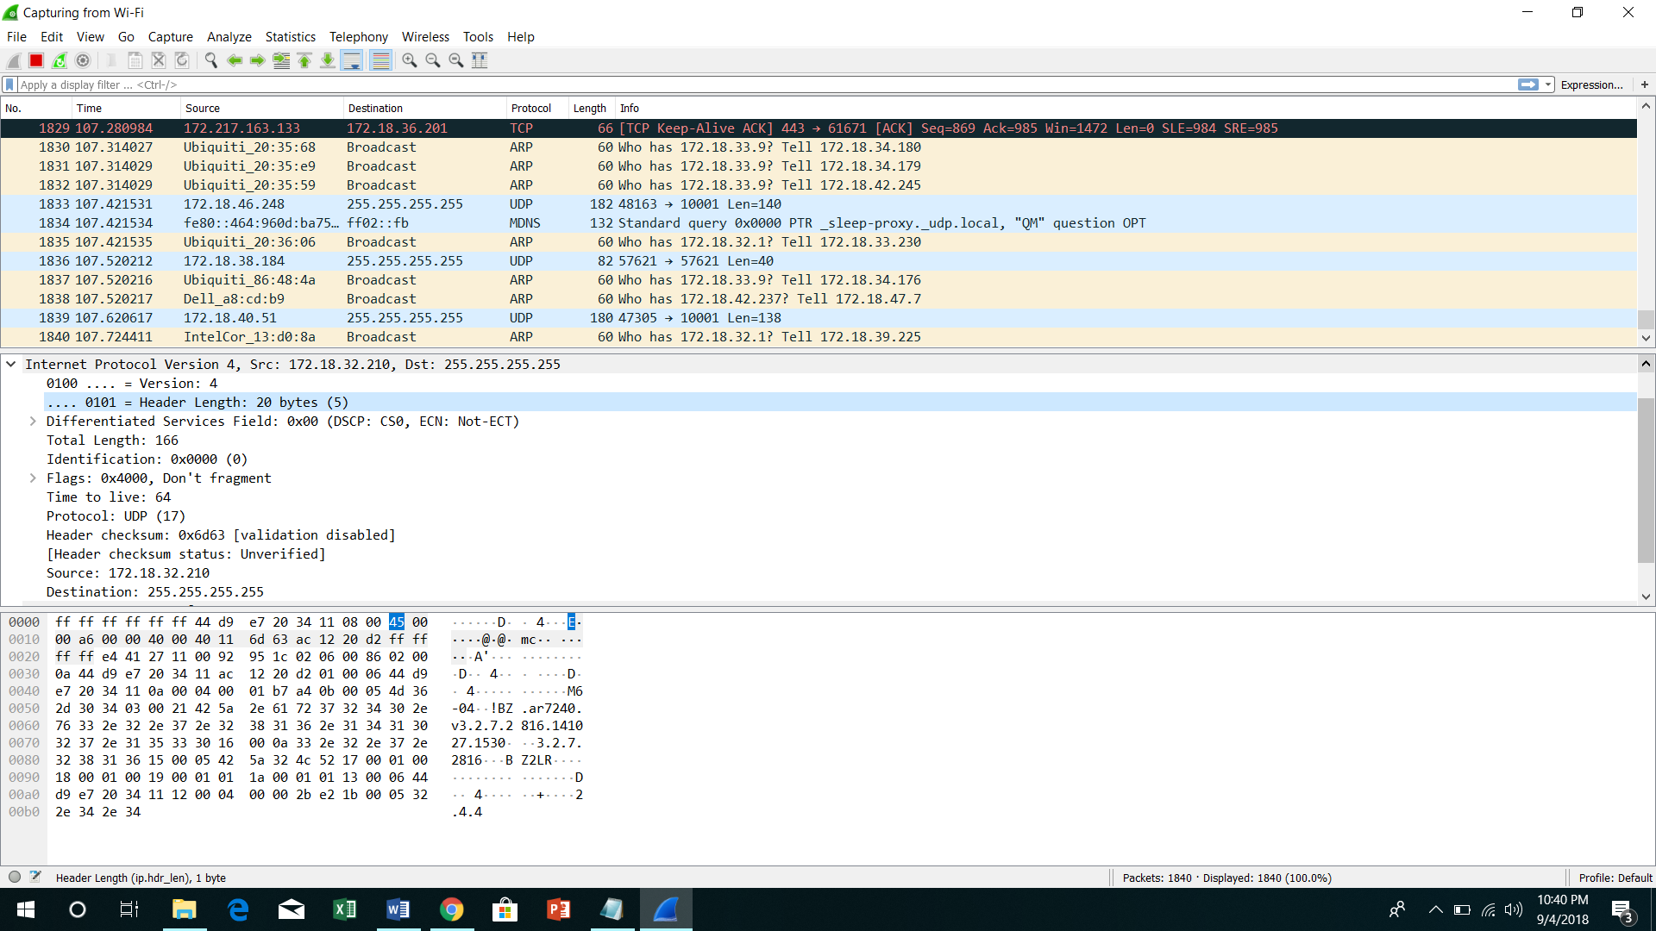

* TCP

|  |  |  |  |  |  |
| --- | --- | --- | --- | --- | --- |
|  | | | | | |
| 443 | | | 49865 | | |
| 3730 | | | | | |
| 1327 | | | | | |
| DATA OFFSET | Not set | 0×0000 | | 254 | |
| 0×7619 | | | | 0 | |
| OPTIONS | | | | | PADDING |
| DATA | | | | | |

* UCP

|  |  |
| --- | --- |
|  | |
| 58433 | 10001 |
| 146 | 0×d242 |
| DATA | |
|  | |
|  | |

RESULT:

Exercise No: 10 Date:

**DEMONSATRATION OF PING OPERATION USING ICMP IN WIRE SHARK**

AIM:

PROCEDURE:

1. Launch the wire shark application.
2. Start live capturing of packets.
3. Go to command prompt.
4. Type ping IP address of the neighboring system.
5. Wait until the ping operation gets terminated.
6. Return back to wire shark application.
7. Type ICMP in the filter window.
8. Analyze the request and reply packets using ICMP header format.

ICMP HEADER FORMAT:

|  |  |  |  |  |  |
| --- | --- | --- | --- | --- | --- |
|  | | | | | |
| Version | IHL | TDS/DSCP/ECN | | TOTAL LENGTH | |
| IDENTIFICATION | | | | FLAGS | FRAGMENT OFFSET |
| TIME TO LIVE | | PROTOCOL | | HEADER CHECKSUM | |
| SOURCE ADDRESS | | | | DESTINATION ADDRESS | |
| TYPE | | | CODE | CHECKSUM | |

OUTPUT:

* Request-

|  |  |  |  |  |  |
| --- | --- | --- | --- | --- | --- |
|  | | | | | |
| 4 | 20 bytes | DSCP-default(0) | | 60 | |
| 0×1115(4373) | | | | 0×0000 | 0 |
| 128 | | ICMP(1) | | 0×6202(Validation disabled) | |
| 172.18.62.70 | | | | 172.18.49.63 | |
| 8(Echo(ping)request) | | | 0 | 0×4d52(correct) | |

* Reply:

|  |  |  |  |  |  |
| --- | --- | --- | --- | --- | --- |
|  | | | | | |
| 4 | 20 bytes | DSCP-default(0) | | 60 | |
| 0×1965(6501) | | | | 0×0000 | 0 |
| 128 | | ICMP(1) | | 0×59b2 | |
| 172.18.62.70 | | | | 172.18.49.63 | |
| 0(Echo(ping)reply) | | | 0 | 0×5552(correct) | |

RESULT:

Exercise No: 11 Date:

**CONFIGURATION OF DOMAIN NAME SERVICE**

AIM:

PROCEDURE:

1. Open Control Panel.

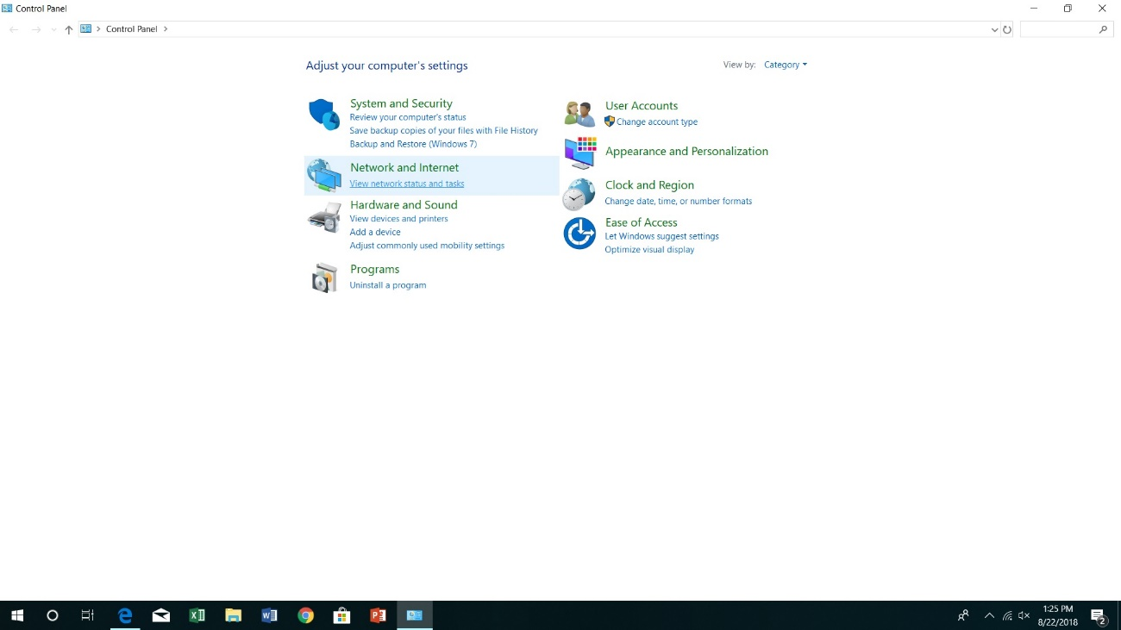

1. Click on **Network and Internet**.
2. Click on **Network and Sharing Center**.

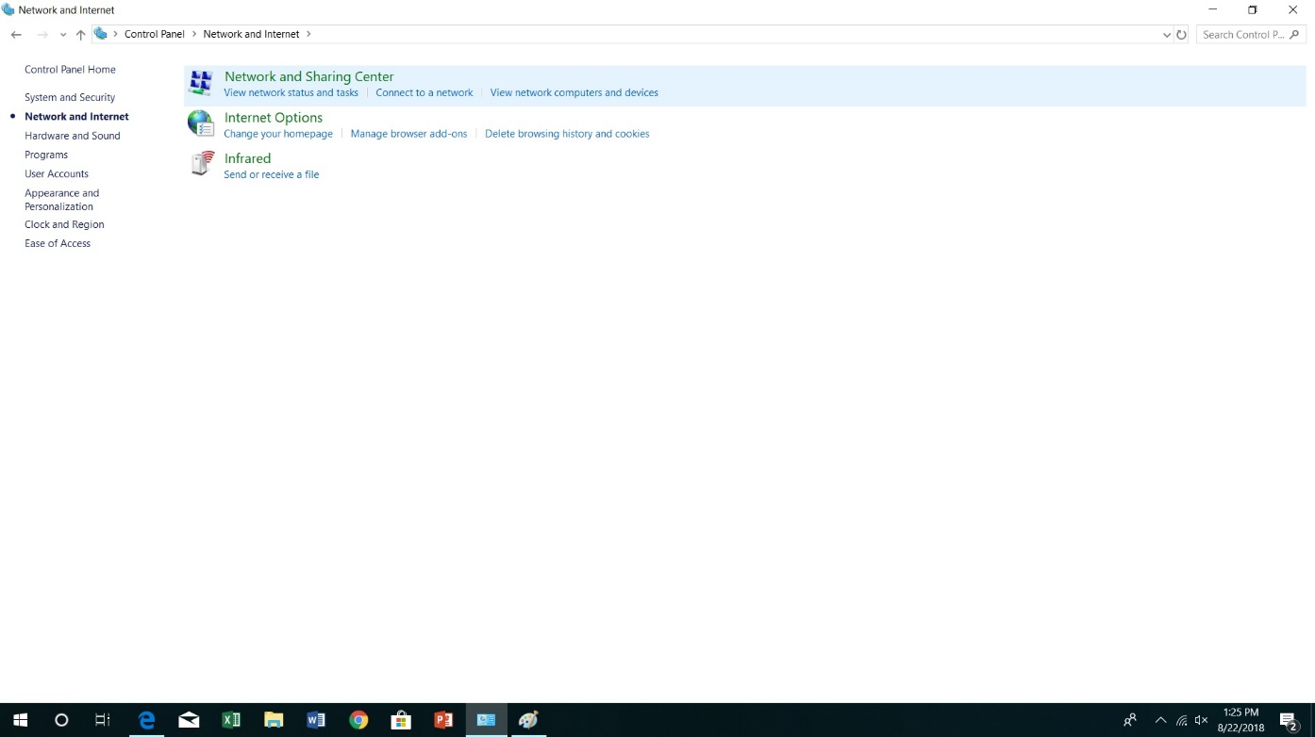

1. On the left pane, click on **Change adapter settings**.

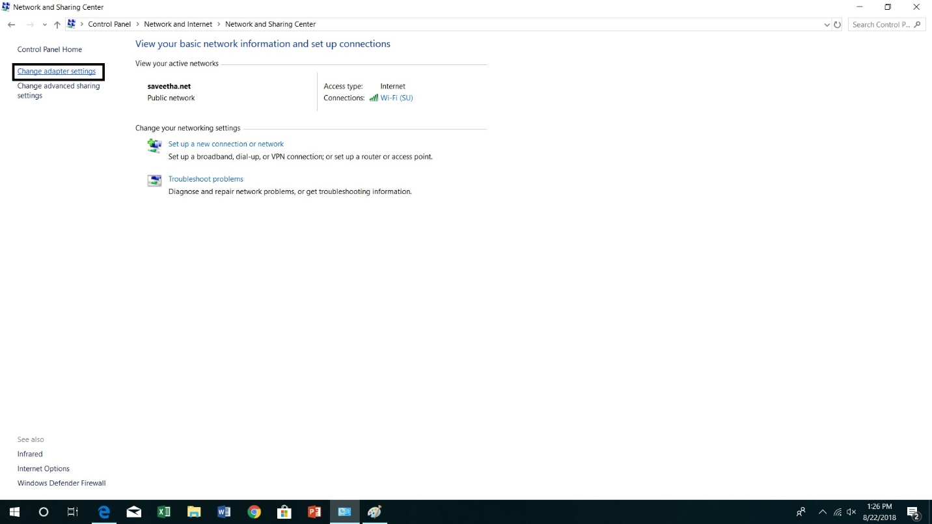

1. Right click the network interface connected to the internet, and select **Properties** (here, WIFI).

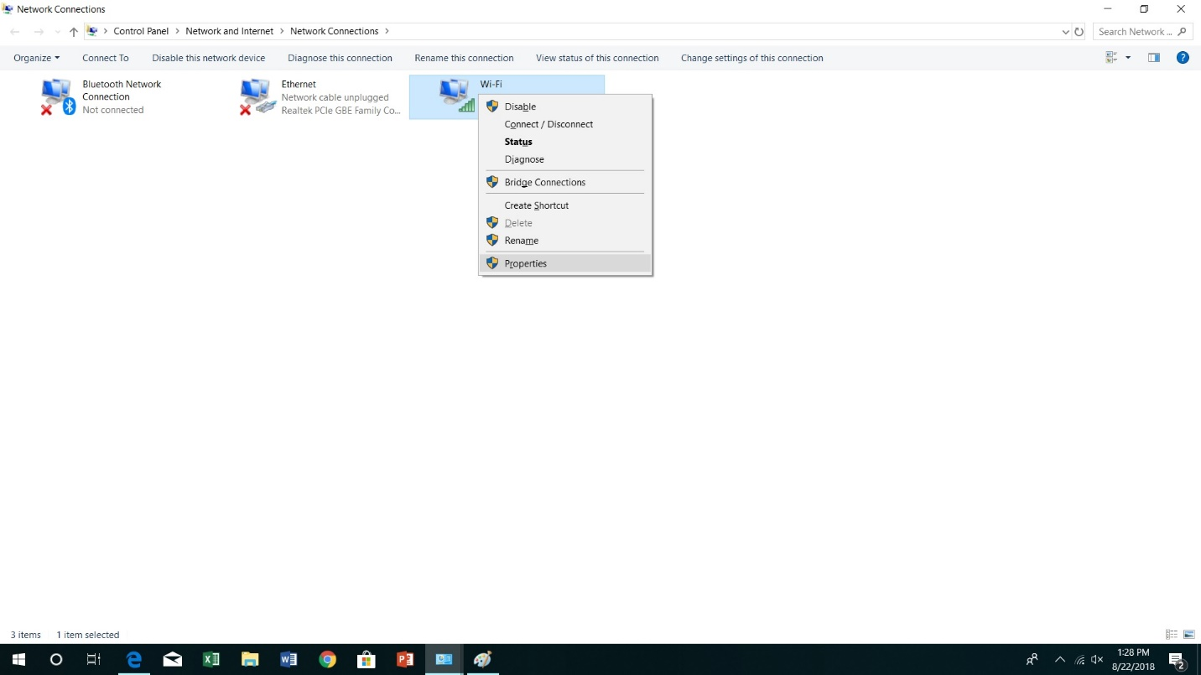

1. Select **Internet Protocol Version 4(TCP/IPv4)** from the list.

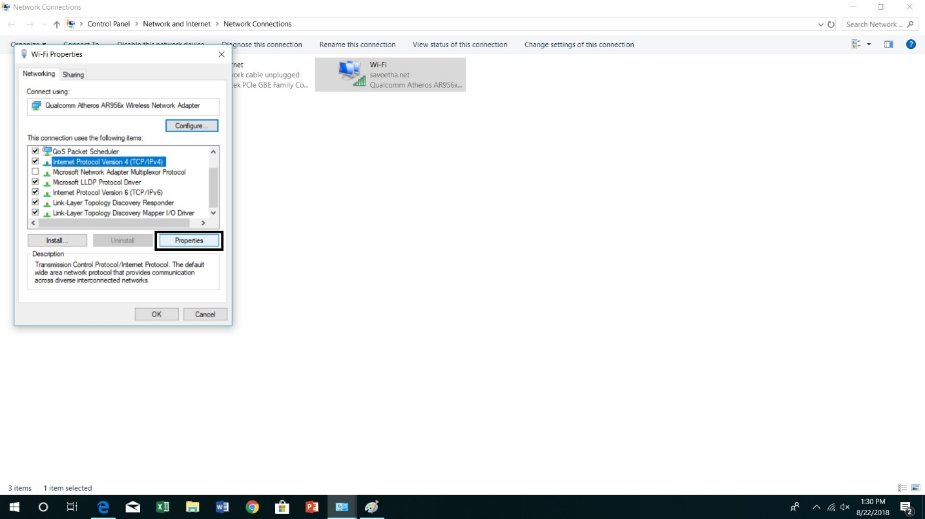

1. Click the **Properties** button.
2. Click the **Use the following DNS server addresses** option.

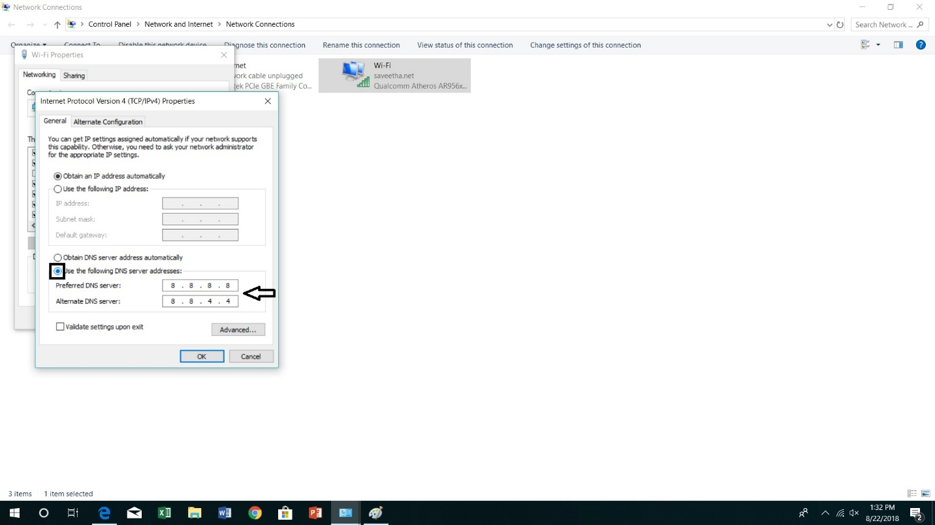

1. Type your preferred and alternate DNS server addresses. Here we have entered the Google Public DNS.

* Google Public DNS addresses : 8.8.8.8 and 8.8.4.4

1. Click OK.
2. Click on Close to apply the new DNS settings to the adapter.

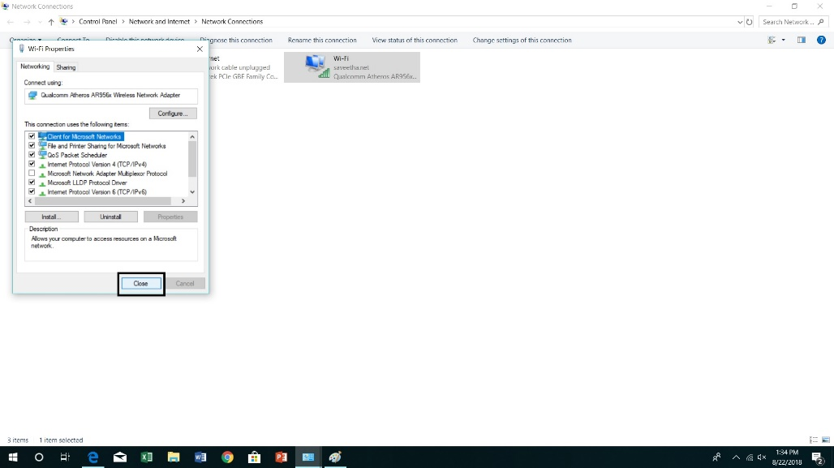

* Once you complete these steps, your computer will immediately start using the DNS settings.

OUTPUT:

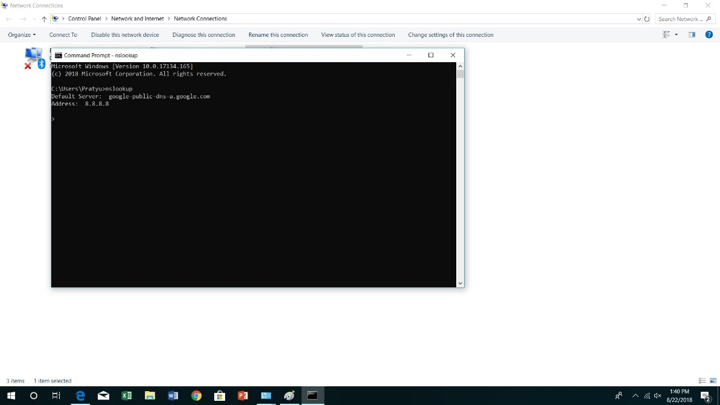

RESULT:

Exercise No: 12 Date:

**CONFIGURATION OF DHCP (DYNAMIC HOST CONFIGURATION PROTOCOL) IN PACKET TRACER**

AIM:

PROCEDURE:

1. Start
2. Select the required end devices and network devices
3. Connect the devices accordingly to their functioning i.e., straight through cable

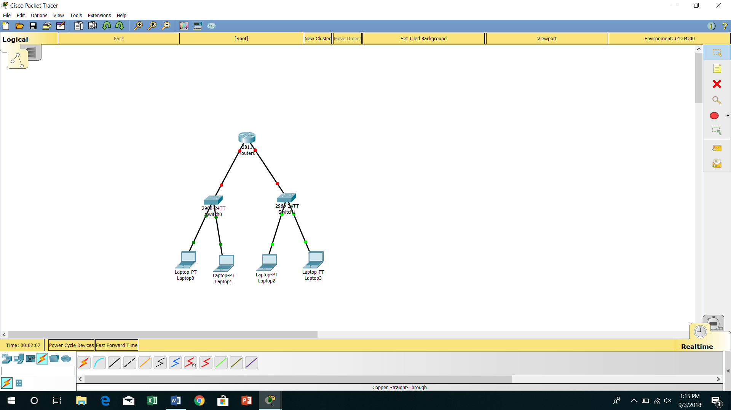

1. First we have to configure DHCP service on the router, so we will first enable the two interfaces and place their respective ip addresses with their subnet mask
2. Now you will proceed to enable a logical interface and very useful since these area always on if the router is on too. But it is good practice to always make sure that the logical interface is turned on

By using the command

Int loopback 1

IP address 1.1.1.1 255.255.255.255

No shutdown”

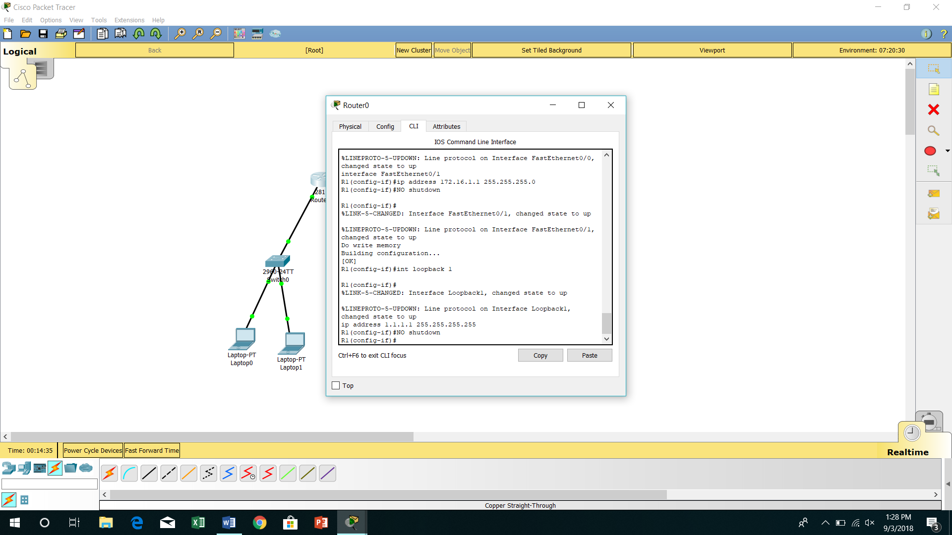

1. To configure the DHCP you must know which ip address we want to provide,which is the subnet mask and which is th e gateway on network
2. As optional we can also exclude ,certain ip addresses to reserve them on simply because we do not want to use them and we can also configure a DNS server where we will place an address

Use the command

“ In DHCP excluded-address 172.16.0.1 172.16.0.10

In dhcp pool NET1

Network 172.16.0.0 255.255.255.0

Default Router 1.1.1.1

DNS server 8.8.8.8

Exit “

Similarly we use for Net 2

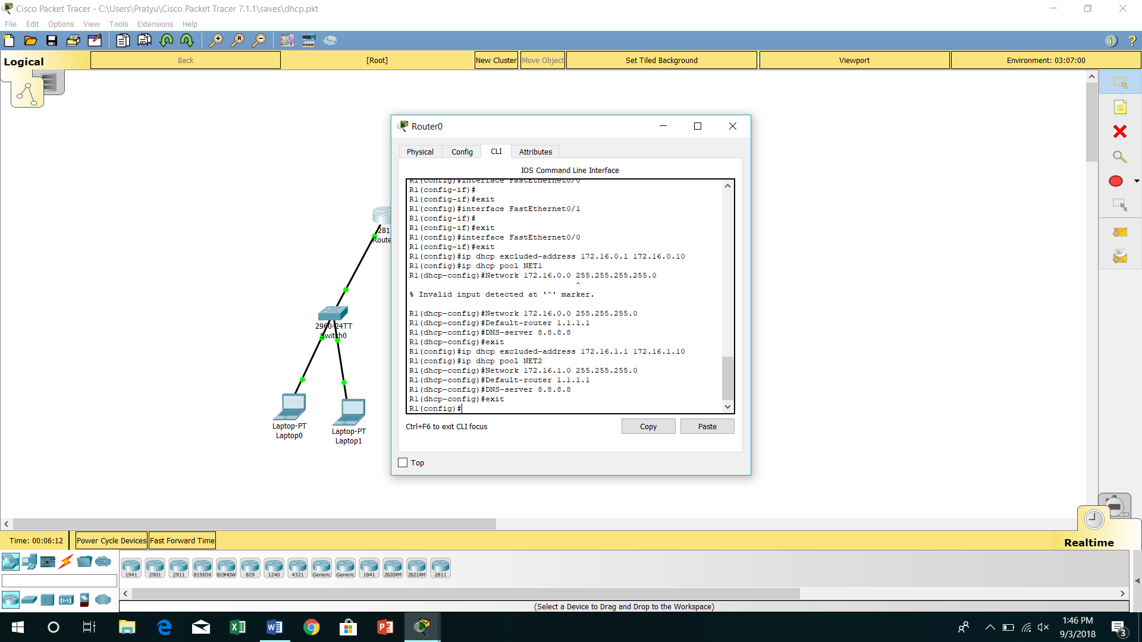

1. We now need to require dhcp services on the respective physical interfaces of the router
2. We must be very careful that we are requiring the DHCP service in the correct interface matches the address of the interface the address of DHCP together with subnet mask

“ int fa0/0

Ip helper-address 1.1.1.1”

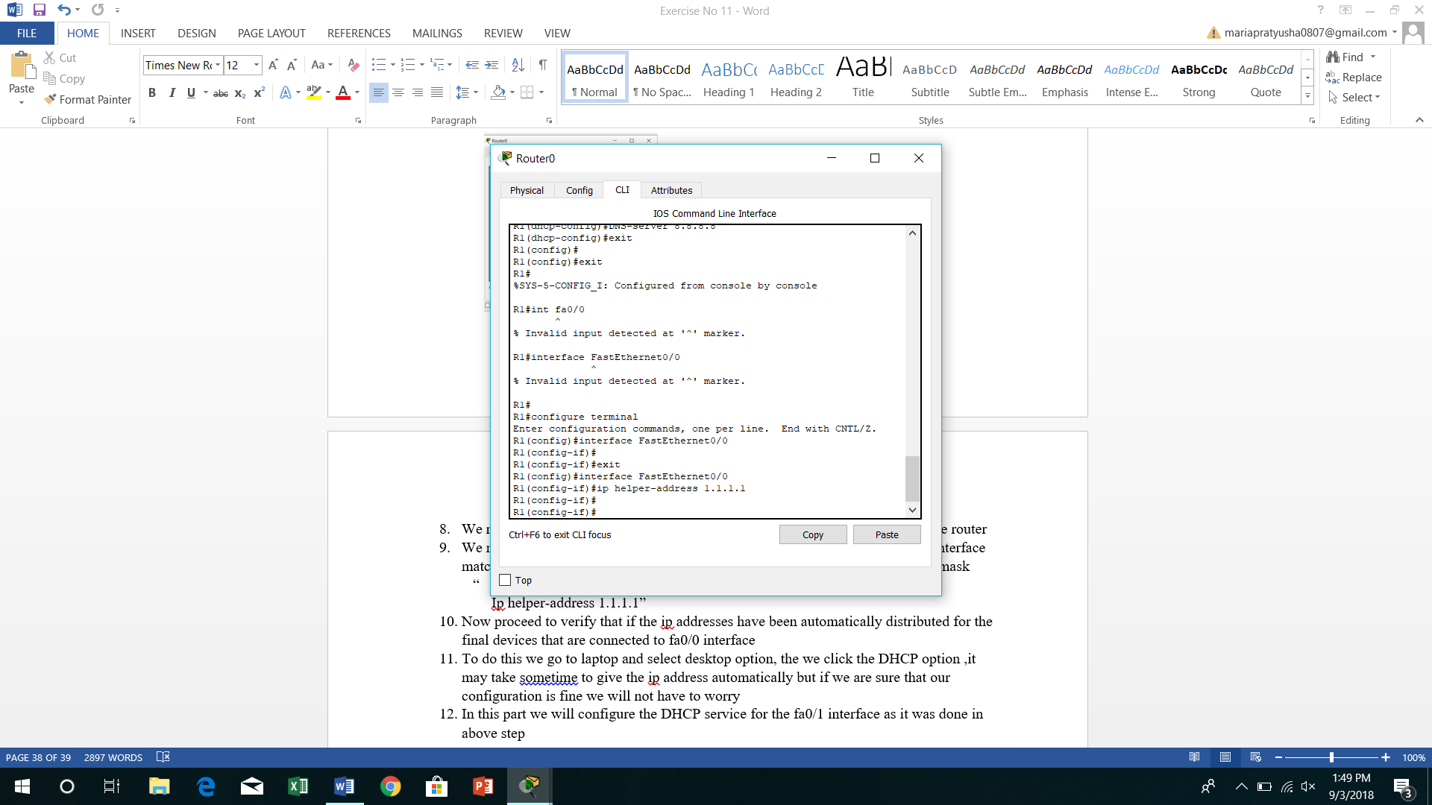

1. Now proceed to verify that if the ip addresses have been automatically distributed for the final devices that are connected to fa0/0 interface
2. To do this we go to laptop and select desktop option, the we click the DHCP option ,it may take sometime to give the ip address automatically but if we are sure that our configuration is fine we will not have to worry

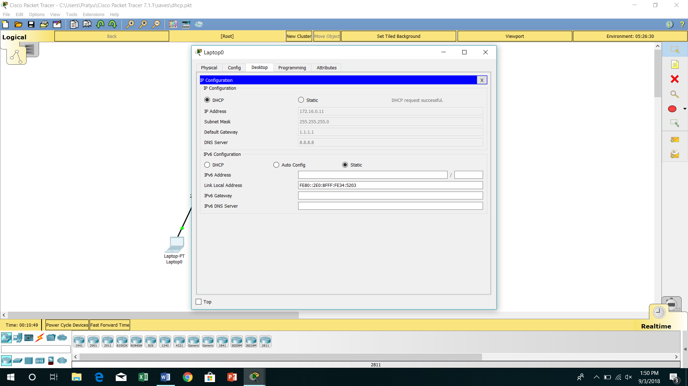

1. In this part we will configure the DHCP service for the fa0/1 interface as it was done in above step

“ int fa0/1

Ip helper-address 1.1.1.1

Do write memory”

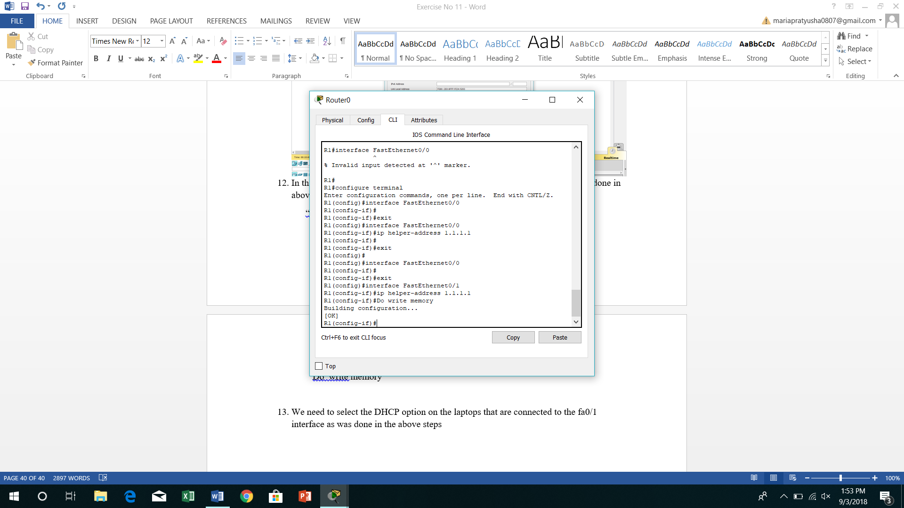

1. We need to select the DHCP option on the laptops that are connected to the fa0/1 interface as was done in the above steps

OUTPUT 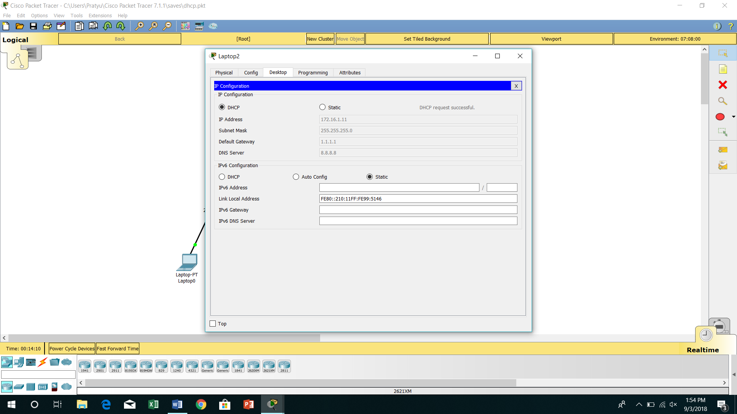

RESULT:

Exercise No: 13                                                                                                                                    Date:

**CONFIGURATION OF FIREWALL IN PACKET TRACER**

AIM:

PROCEDURE:

1.      Start Packet Tracer

2.      Choose required end devices and network

3.      Select the devices accordingly

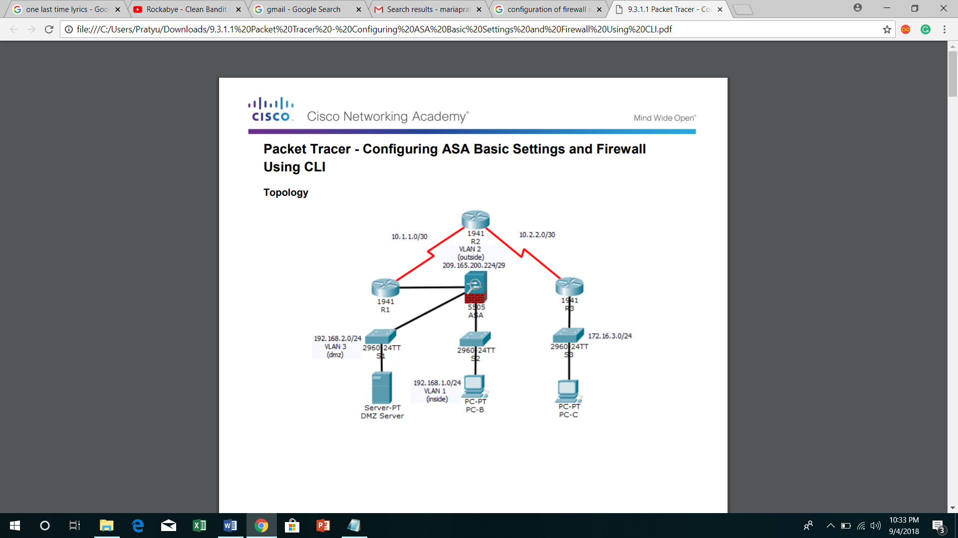

4.      Give the serial ports serial0/1/0 and serial 0/1/1 and connect the routers

5.      Configure the systems(end devices) and DMZ server

6.      Now configure routers using the commands required in CLI commands

7.      Also give gateway (Default Gateway) for DMZ server and end devices

8.      Configure hostname (CCNAS-ASA) and Domain name ([ccnasecurity.com](http://ccnasecurity.com/))

9.      Configure enable mode password

10.  Set the date and time

11.  Configure inside and outside interfaces with the security-level 100 for vlan-1 and security –level 0 for vlan-2

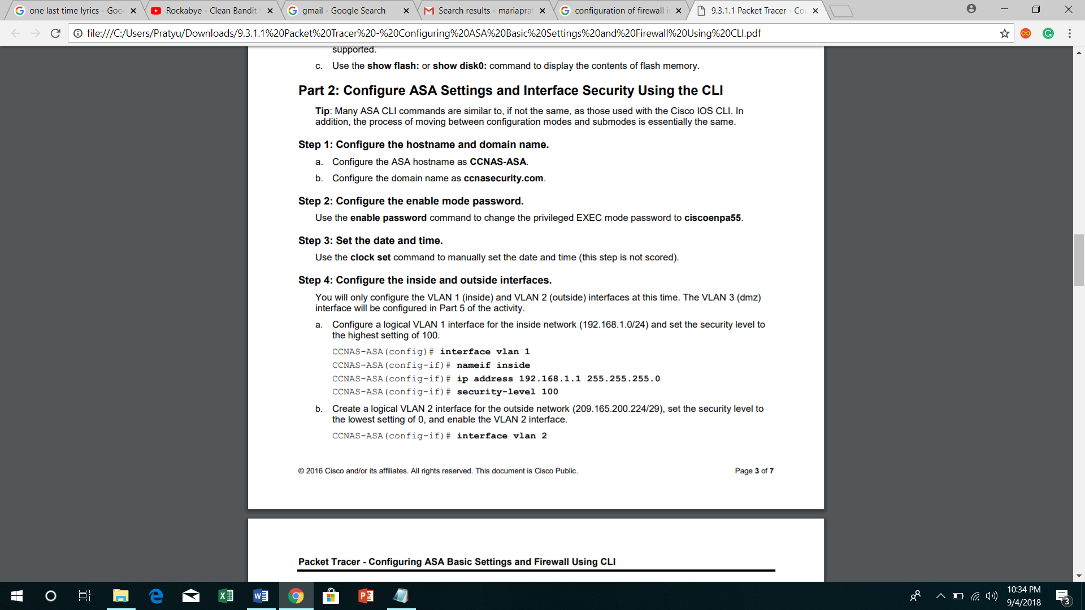

12.  Test connectivity to the ASA

13.  We should ping PC0 with vlan-1

14.  And for PC0 pinging operation vlan-2 should fail

OUTPUT:

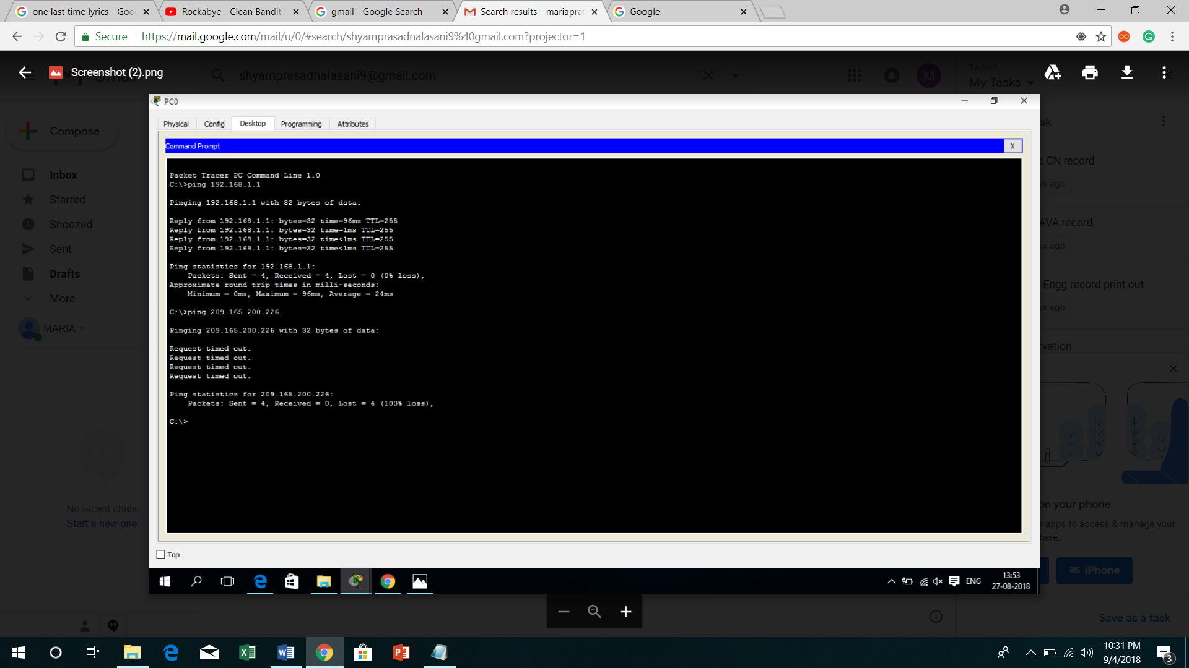

RESULT: